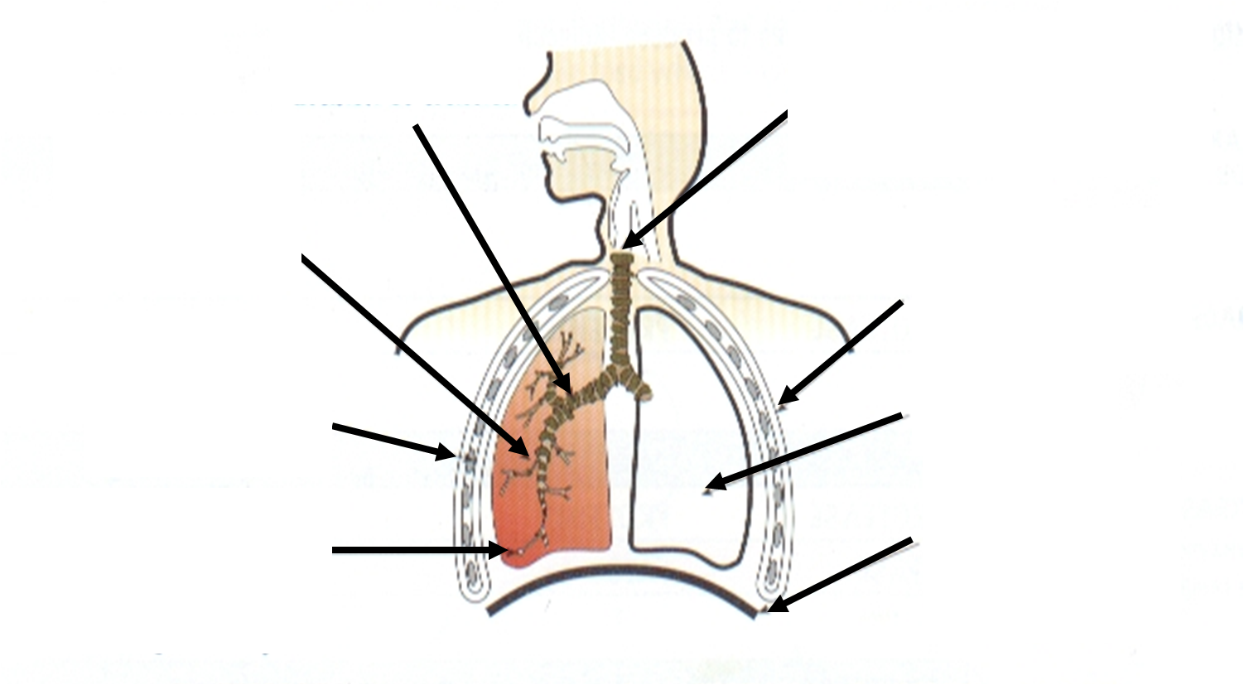

A Breath of Fresh Air!! Name:…………………………

Label the above diagram of the respiratory system using these words.

Trachea bronchi
Lung rib muscles
Diaphragm alveoli ‘air sacs’
Ribs
Bronchioles

